89.07.00a
To the Gardeners' Chronicle

[The accompanying illustration (fig. 36, p. 251) represents, on a reduced scale, a branch of Banksia marginata, for which we are indebted to Baron Von Mueller. It will be seen that the upper surface of the leaf is rolled back from the tip towards the base.]

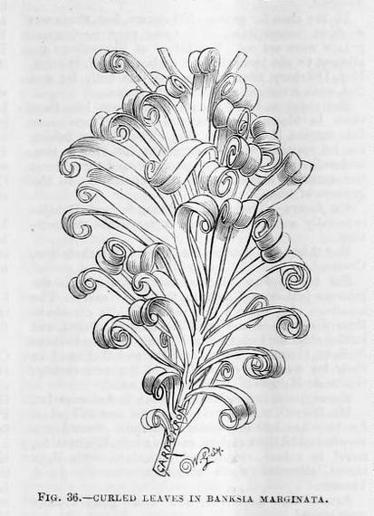

Banksia marginata

Letter not found. For the text given here, see 'Curled leaves', Gardeners' chronicle, 31 August 1889, p. 250. It is dated to July as the latest likely date for the letter to have been sent for it to be reported in this issue.
89-07-00a_image01.jpg.
The anonymous article continues by discussing other cases of curled leaves, with a comment on the mechanism that produces the effect, although the mechanism 'does not help us to the reason why'.

